
Safety Bay Senior High

Physics - Unit 2
Motion Test
Total Marks /62
Question 1 (2 marks)
Jamie can accelerate his bicycle from rest at 0.565 m s⁻². How far will he have travelled by the time he achieves a speed of 6.8 m s⁻¹? (2 marks)

Question 2 (2 marks)
Explain why in a vacuum a bowling ball and a feather fall down at the same rate.
(2 marks)

Question 3 (2 marks)
Victoria works in Coles doing night fill. She has to lift three 1.50 kg boxes of laundry detergent from the floor to the shelf 1.10 m above the floor. If it took 1.50 seconds to lift all boxes at once to the shelf, what power was required? (2 marks)

Question 4 (2 marks)
Explain why seatbelts are important for safety in cars. (2 marks)

Question 5 (10 marks)
Theresa is driving her car of total mass 1500 kg at 16.7 m s⁻¹ on a level road when she released her foot from the accelerator, out the gear into neutral and ‘free-wheeled’ along the road until the car stopped. (Do not try this)
- What is the initial Kinetic energy of the car? (2 mark)

- Calculate the stopping force (assumes constant) if the car travelled 120 m before stopping.
(4 marks)

- What is the time taken to stop the car? (2 marks)

- Calculate the work done in stopping the car. (2 marks)

Question 6 (2 marks)
When a cat lands on the ground from a great height, they instinctively hit the ground feet first and progressively collapse. Explain why this generally helps the cat sustain few injuries. (2 marks)

Question 7 (8 marks)
Tyrone is practising his weightlifting by lifting a 102 kg barbell a distance of 2.3 m from the floor. He completes the lift in 1.85 seconds, holds the barbell for about 3 seconds and then allows it to drop to the floor.
a) How much work has Tyrone done in lifting the barbell? (2 marks)

b) What is Tyrone s power rating during the lift? (2 marks)

c) How much Potential energy does the barbell have while being held up at the height of 2.3 m?
(1 marks)

d) When the barbell is dropped what is the maximum velocity it will gain? (3 marks)

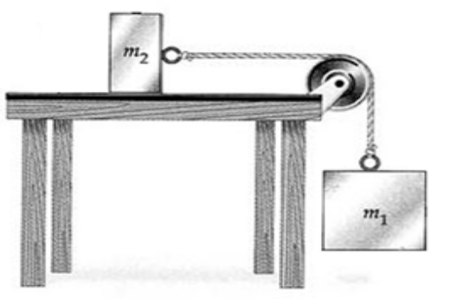Question 8 (4 marks)
A 4 kg mass (m₁) is used to accelerate a 2 kg block of wood on a table (m₂), as shown in the diagram. The 4 kg mass is attached to a string on a pulley at the end of a bench. Assume there is no frictional force from the bench.
- Calculate the acceleration of the wooden block. (2 marks)

- Calculate the tension in the string. (2 marks)

Question 9 (3 marks)
A car of mass 1200 kg is travelling 65 km h⁻¹ when it hits a solid concrete wall, stopping suddenly. What is the change in momentum during the collision? (3 marks)

Question 10 (9 marks)
In a game of marbles, two kids throw their marbles into the rink at the same time. The dark spot marble and the light spot marble are of the same mass collide with the velocities shown in the diagram and carry on moving.

3.0 m s⁻¹
2.0 m s⁻¹

Light Spot
Dark Spot

After the collision the dark spot marble continues to move in the same direction, but with its velocity reduced to 0.25 m s⁻¹.
a) Calculate the final velocity of the light spot marble. (3 marks)

b) Determine if the collision is elastic or inelastic (show mathematical working). (6 marks)

Question 11 (3 marks)
If a karate master attempts to break a stack of 10 bricks in one strike. Explain why it is important for the master to break all the bricks and why he will be in trouble if there was even one brick left unbroken.

Question 12 (5 marks)
A basketball of mass 400 g is thrown vertically downwards at the ground at a speed of 8.5 m s⁻¹. The ball rebounds upwards at a velocity of 8.0 m s⁻¹.
- What is the change of momentum of the ball? (3 marks)

- If the ball was in contact with the floor for 250 ms, what force was exerted on it? (2 marks)

Question 13 (10 marks)
A car of mass 800 kg is travelling at 75.0 km h⁻¹ and slows down to 40 km h⁻¹ as it approaches a road work site. The car’s reduced speed is achieved by applying the brakes over a distance of 100 metres.
a) Determine the cars initial Kinetic energy. (3 marks)

b) The work done by the brakes in slowing the car down. (4 marks)

c) The average force applied by the brakes. (3 marks)

